- The ingress-rule.yml file specifies the ingress configuration for your sock-shop
- namespace, using the nginx ingress class.
- Ensure that your NGINX Ingress controller is properly set up in your cluster and that it is configured to listen for ingress resources in the sock-shop namespace

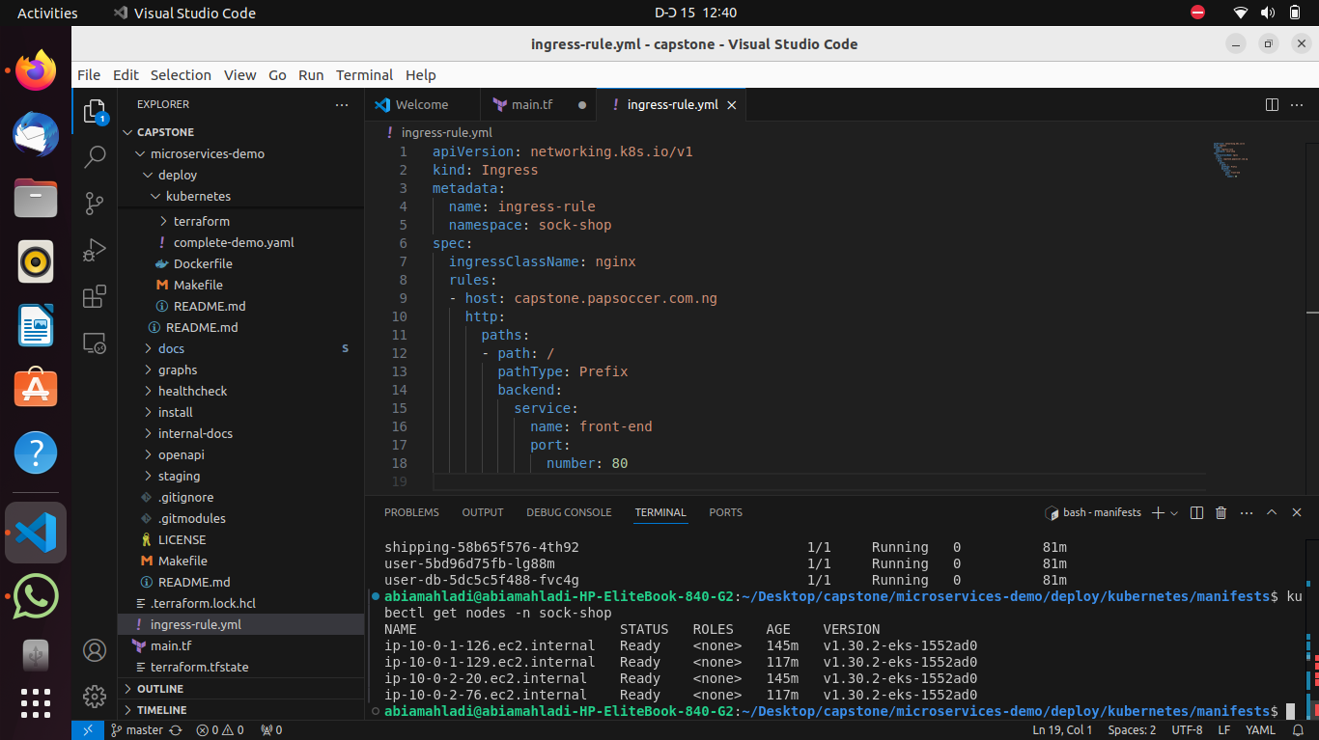
In the screenshot, I deployed multiple Kubernetes pods, and they are all in a running state. I also have the ingress-rule.yml file open, which defines an NGINX ingress resource.
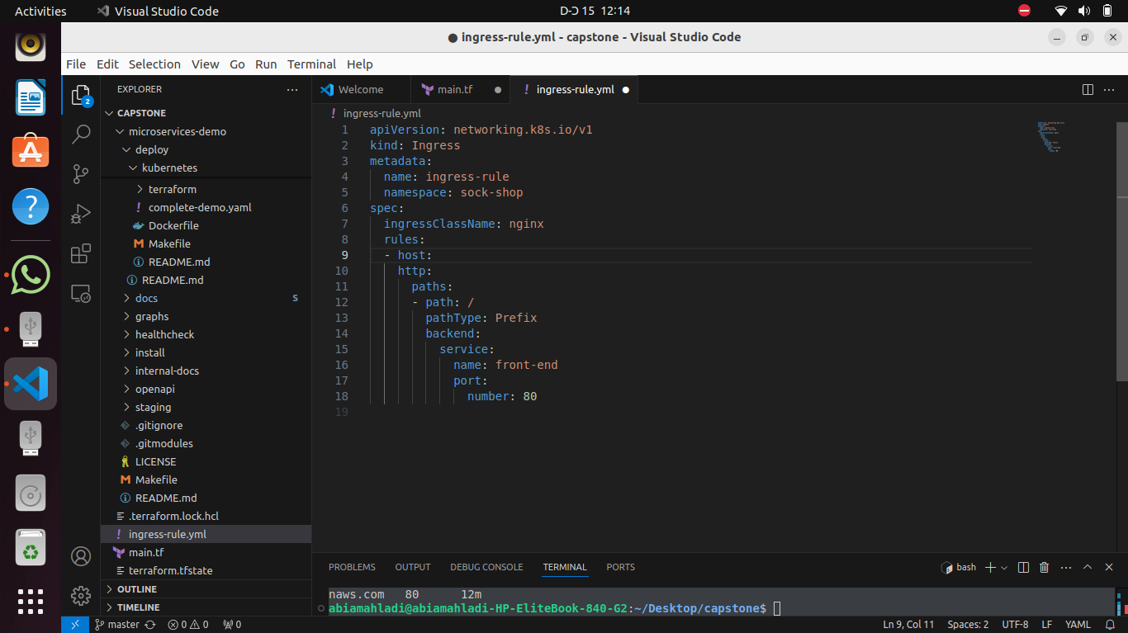
The image shows a YAML file named ingress-rule.yml open in the Visual Studio Code editor. This file defines an Ingress resource for Kubernetes, which is a configuration object used to expose HTTP and HTTPS routes from outside the cluster to services within the cluster.

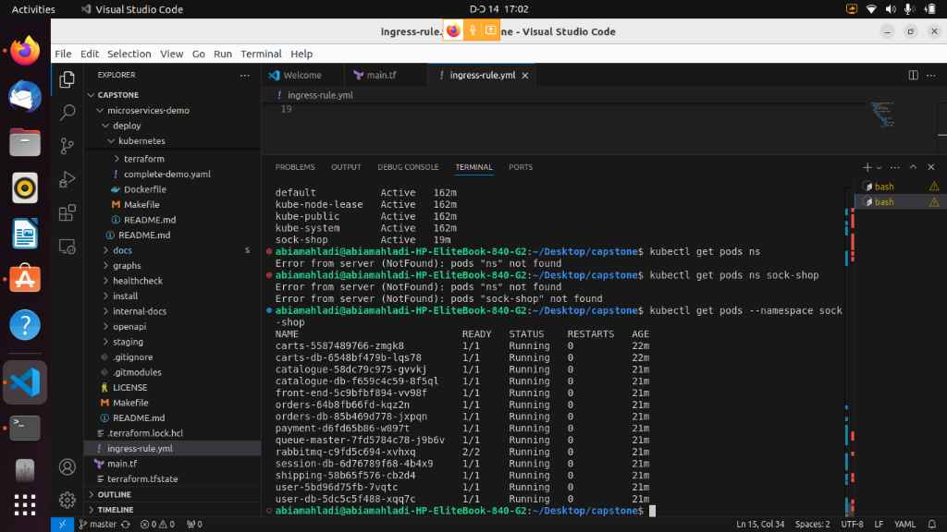
List of pods.
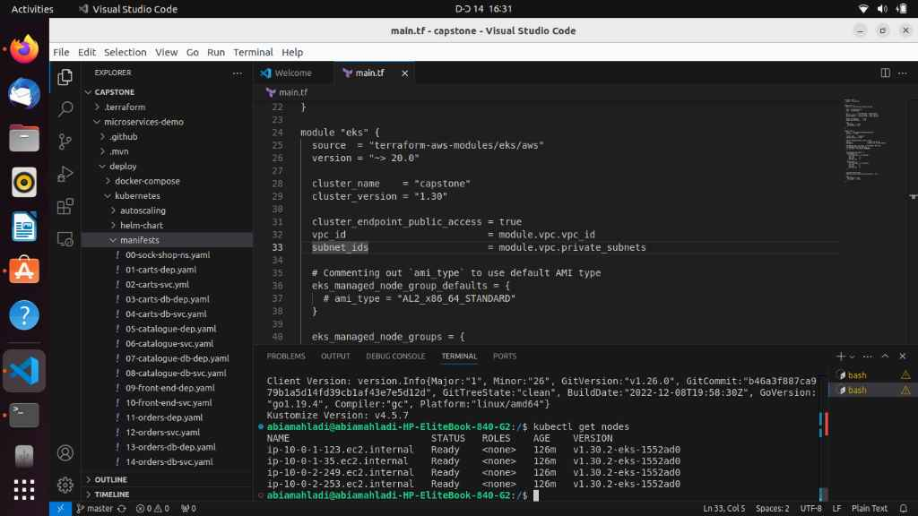
List of Nodes
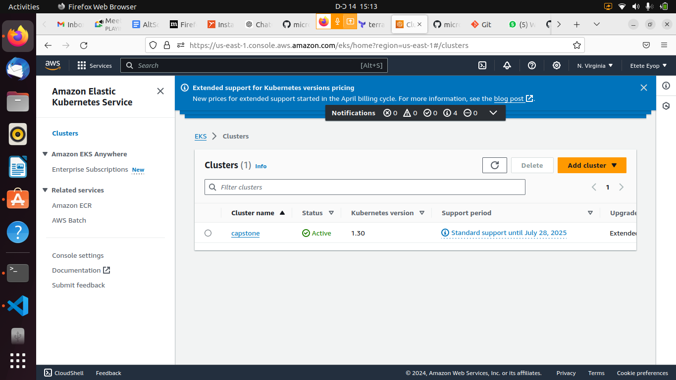
The image displays a section of the Amazon Web Services (AWS) Management Console, specifically focusing on Amazon Elastic Kubernetes Service (EKS) Clusters.

